**

**Mathematics Specialist Unit 1**

# Test 2

**Circle Geometry, Vector Proof and Numerical Proof**

|  |
| --- |
| **Name: ______________________ Total Marks:______/50** |
|  |
|  |

**Task type: Response**

**Time allowed for this task:** 55minutes, in-class, under test conditions

**Materials required:** Calculator with CAS capability (to be provided by the student),

1 A4 page of notes two sided

**Standard items:** Pens (blue/black preferred), pencils (including coloured), sharpener, correction fluid/tape, eraser, ruler, highlighters

**Special items:**  Drawing instruments, templates, notes on one unfolded sheet of   
A4 paper, and up to three calculators approved for use in the WACE examinations

Formula sheet

**Marks available: 50 marks**

**Task weighting: 5%**

**Question 1**

[8 marks]

1. 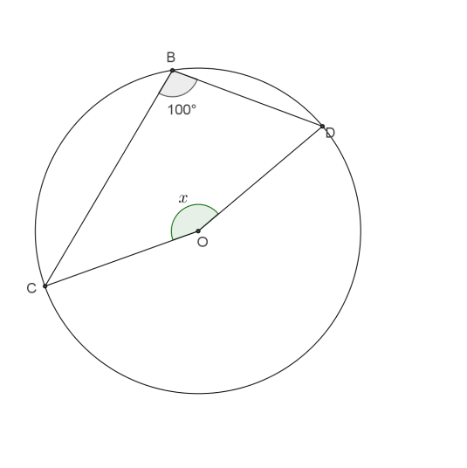Find the value of $x$, showing appropriate reasoning.
2. 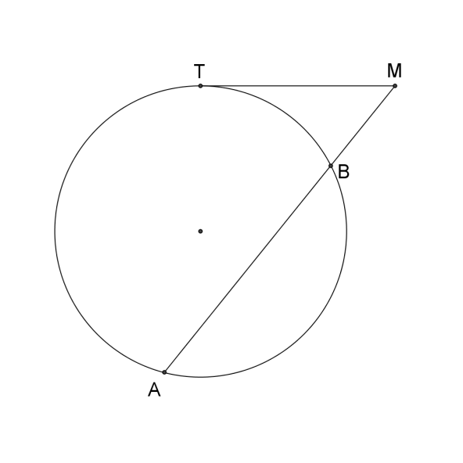Given that TM=6m and BM=4m. Find AB

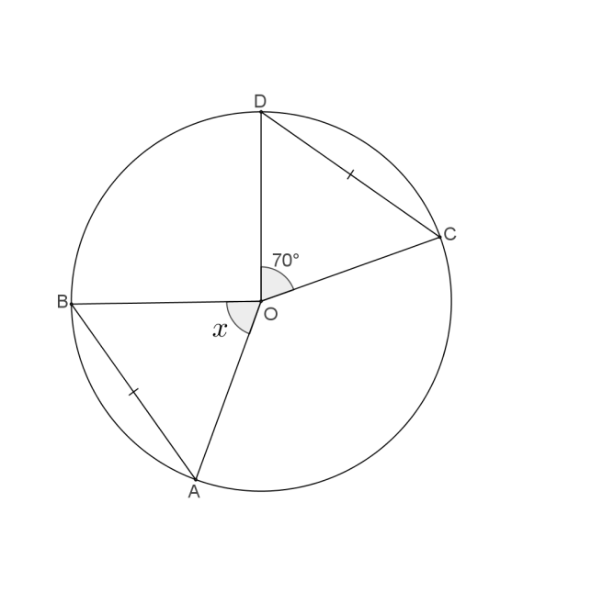

1. Find the value of $x$, showing appropriate reasoning.

**Question 2**

[5 marks]

In the diagram below EA and EC are tangents to the curve

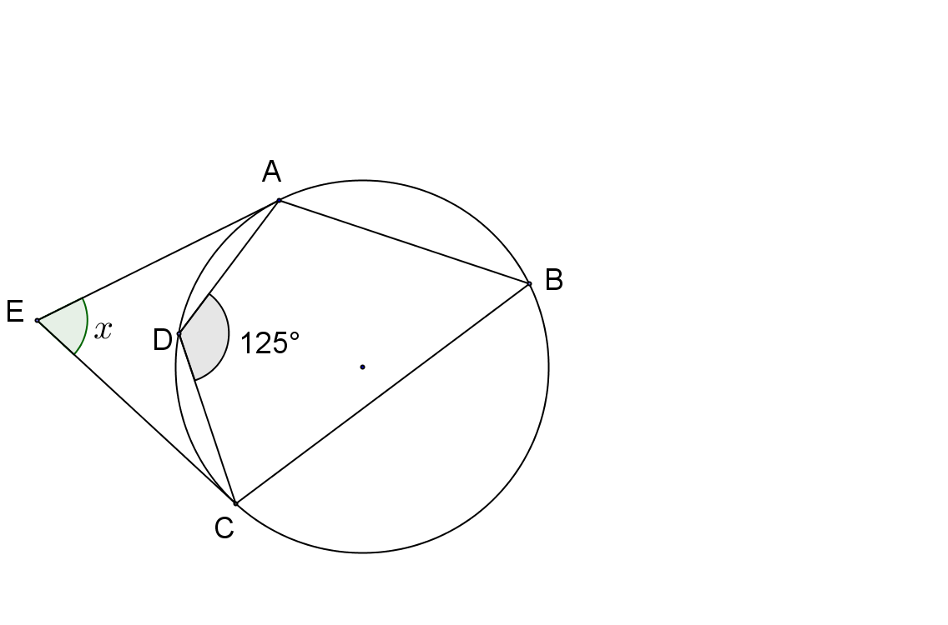 $∠AEC=x° .$ Prove that $x=70$

**Question 3**

[6 marks]

Prove that CE is the diameter of the circle.

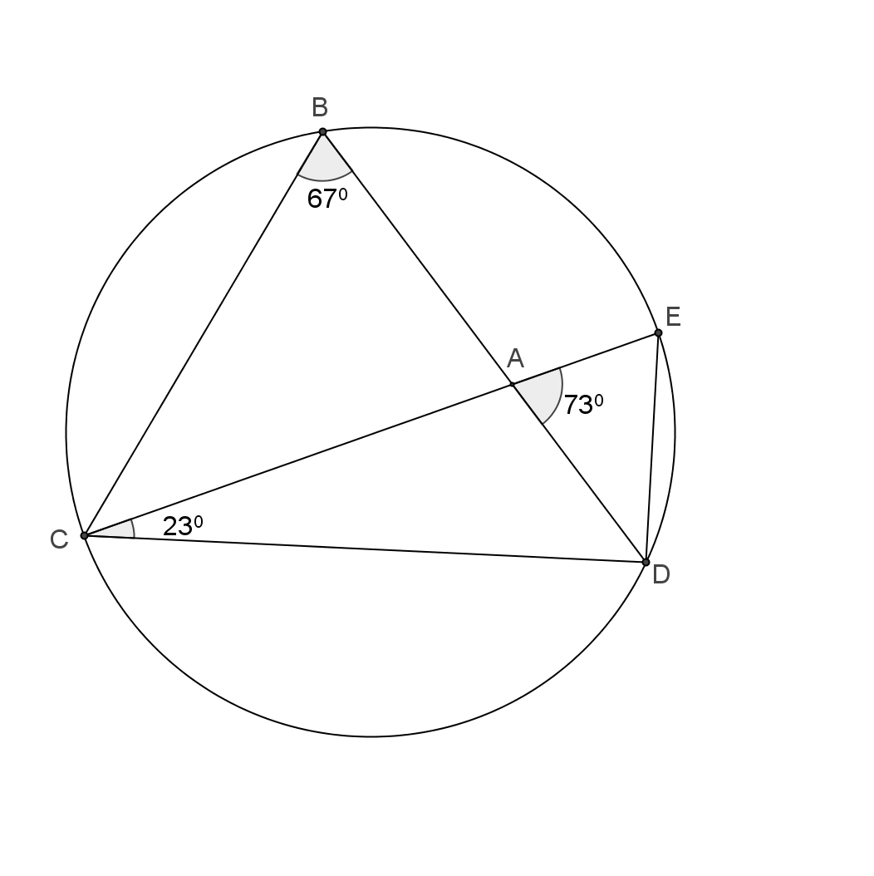

**Question 4**

[8 marks]

1. Prove that $AB×AD=AC×AE$

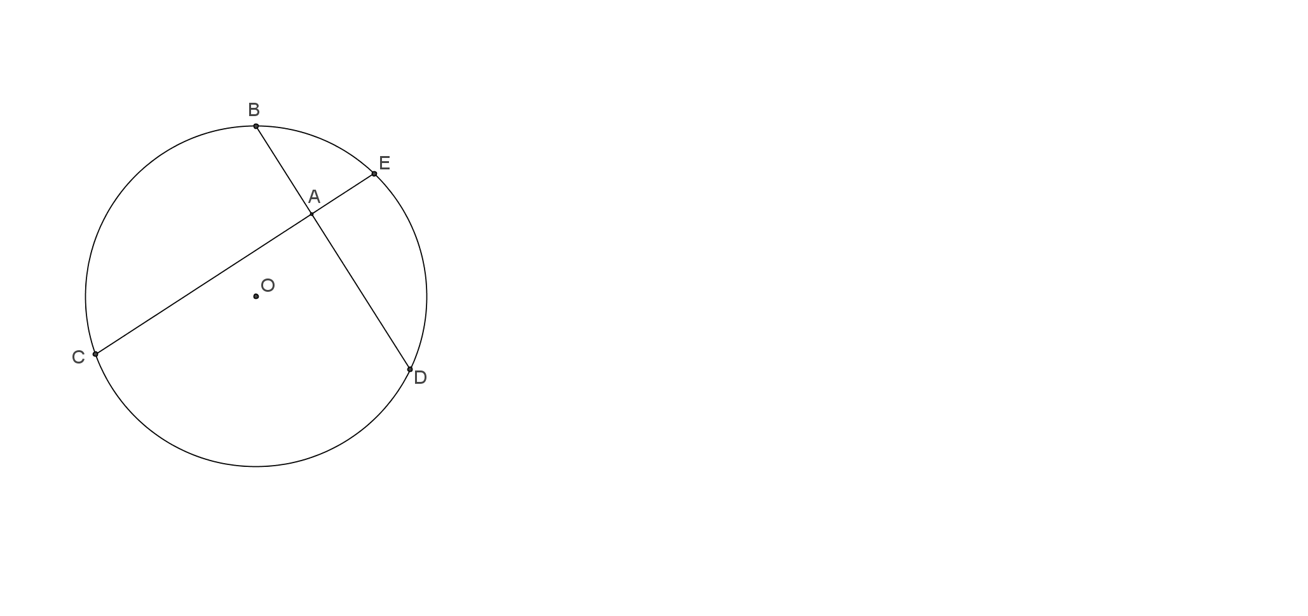

1. Given that AB=4cm, AD=6cm and 2AE=AD. Find the length of EC.

**Question 5**

[5 marks]

Using the method of proof by contradiction, prove that if $3n+2$ is odd then $n$ is odd.

**Question 6**

[6 marks]

Consider the statement

“If a quadrilateral is a square, then it has 4 equal angles”

1. Write the inverse statement.
2. Write the converse statement.
3. Write the contrapositive statement.
4. Which of these statements are false? Give a counter example

**Question 7**

Determine whether or not $A⇔B$

[2 marks]

A: The two triangles are congruent.

B: The two triangles have corresponding angles equal.

**Question 8**  [5 marks]

## In ΔABC, the points M and N divide the sides AB and AC respectively in the ratio 1 : 3.

## Let AB = *u* and AC = *v*. Find BC and MN in terms of *u* and v, and hence prove that BC = 4MN.

## 

**9.**  [5 marks]

In Triangle ABC below, AD = 13 cm, DB = 5 cm, AE = 9 cm and DE = 5 cm.

Prove that BC = 10 cm.

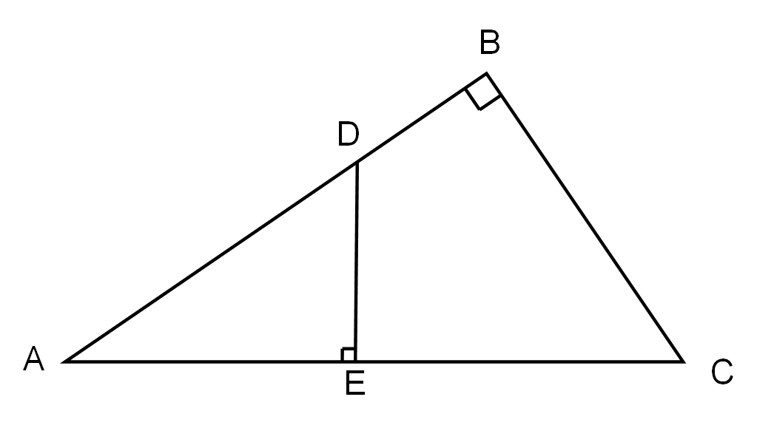

**End of Test**